Lampiran Skor Tingkat Kepentingan

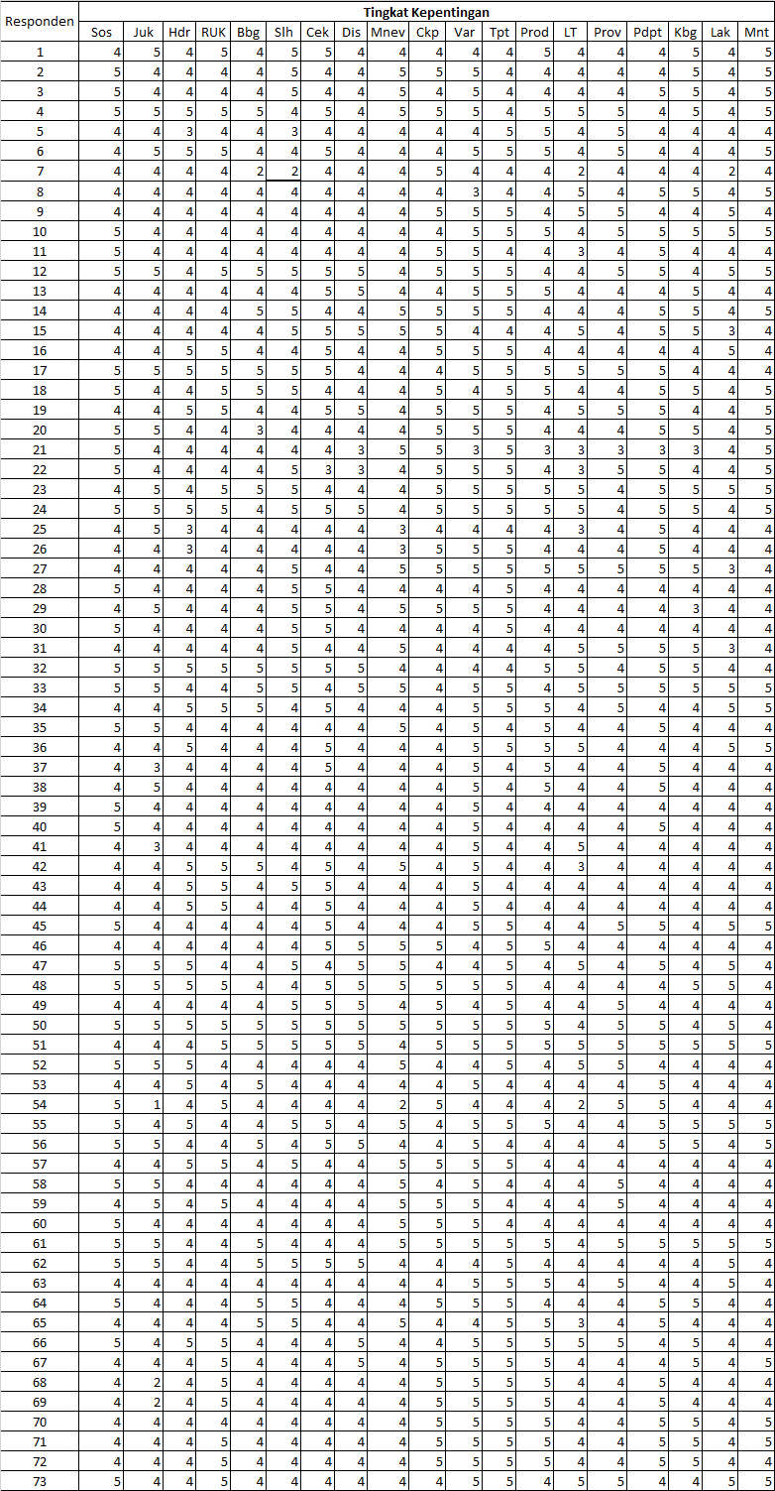

Lampiran Foto-Foto Kegiatan Survey

|  |  |
| --- | --- |
| WhatsApp Image 2021-10-06 at 10 | d6080c9a-7f00-49cc-8f72-8a5093adf74b |
| 2 | 3 |
| 4 | 5 |
| 6 | 7 |